EXPERIMENT 8

SUB QUERY AND CORRELATED QUERY

**OUTPUTS:**

1)

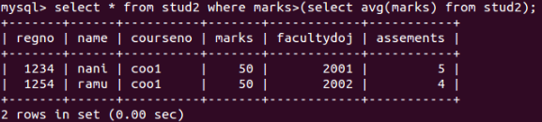

2)

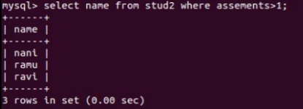

3)

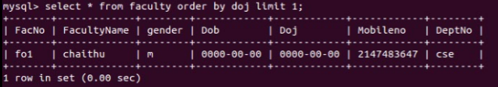

4)

